ITIS 5250

Sahil Bhirud - 801138029

Lab - 3

**Overview:**

In this lab, I have helped Officer Jimmy Johns with his investigation regarding the theft which took place at Woodward Hall. The subject is a shifty looking individual who was spotted by Officer Johns. Officer Johns has provided me with the Forensic Image “**ItemA_thumbdrive.E01**” of the subject’s thumbdrive on which I’ll be performing various examinations after verifying its hash values.

**Forensic Acquisition and Exam Preparation:**

I download the image file from Canvas, calculated and verified the hash values of the files. The software I used for extracting and accessing the information from the image is **Autopsy 4.14.0**. The calculated and stored MD5 hash values and SHA1 hash values are shown below:

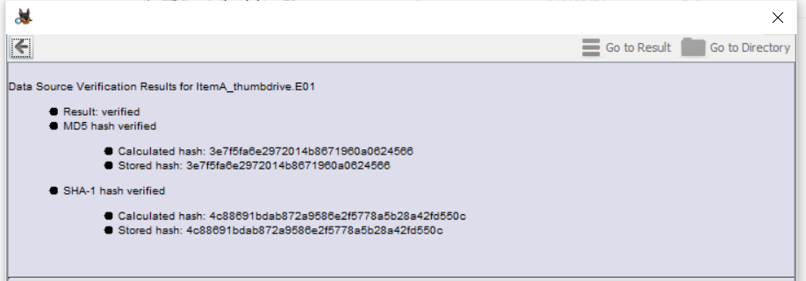

**Findings and Report (Forensic Analysis):**

As I was browsing through the files, I found three pictures that were clicked from or around Woodward Hall. They were located in the main directory (root directory) of the thumbdrive.

**Image 1:**

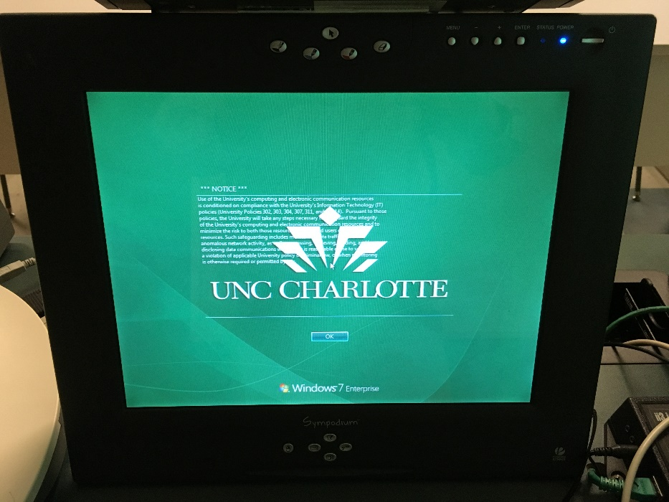

Properties of this image are as follows:

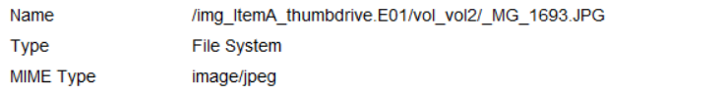

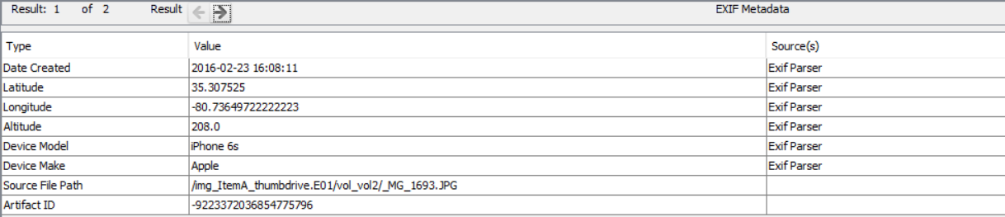

**Name:** _MG_1693.JPG

**Path:** /img_ItemA_thumbdrive.E01/vol_vol2/_MG_1693.JPG

**Device:** Apple iPhone 6s

**Date Created:** 23rd February 2016 at 16:08:11

**Latitude:** 35°18'27.1"N

**Longitude:** 80°44'11.4"W

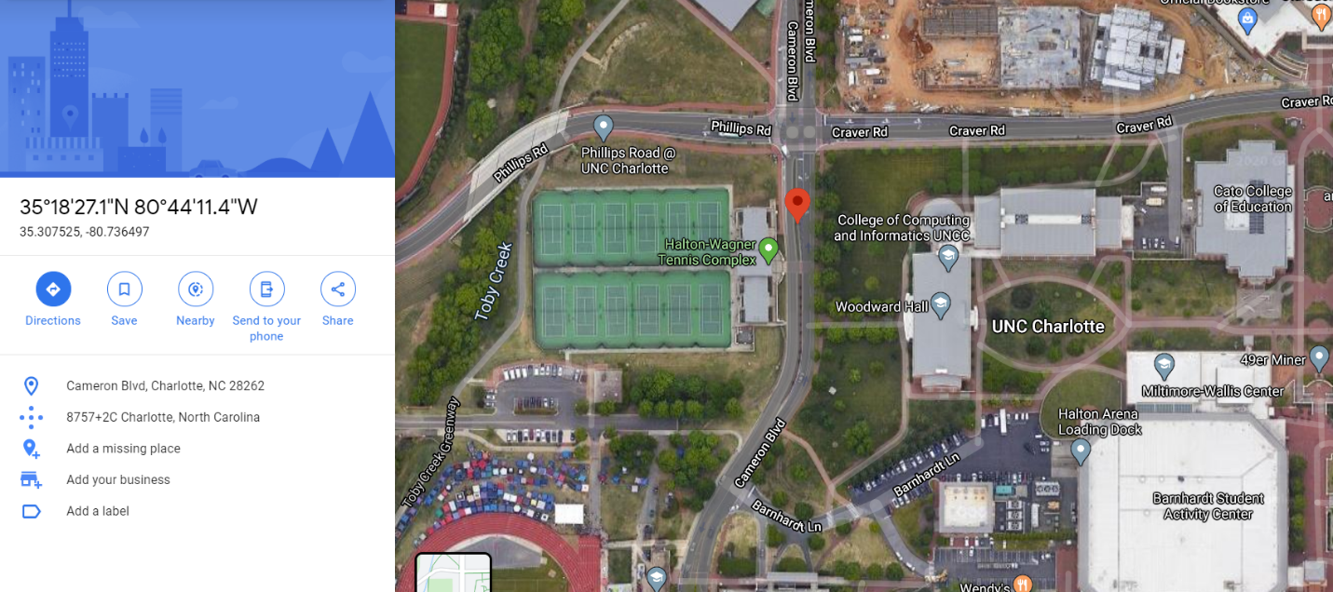

**Image 2:**

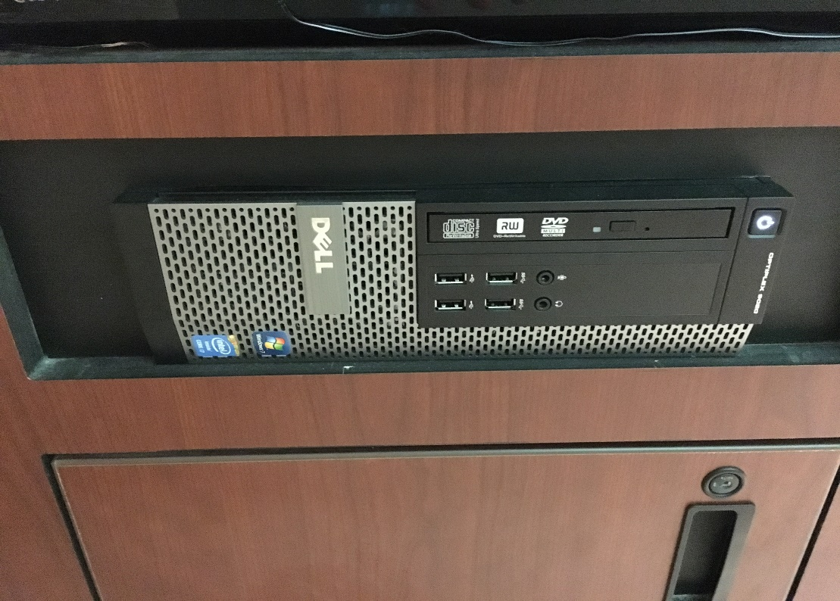

Properties of this image are as follows:

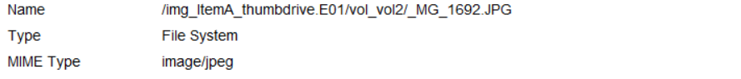

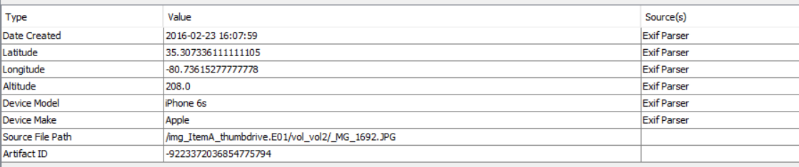

**Name:** _MG_1692.JPG

**Path:** /img_ItemA_thumbdrive.E01/vol_vol2/_MG_1692.JPG

**Device:** Apple iPhone 6s

**Date Created:** 23rd February 2016 at 16:07:59

**Latitude:** 35°18'26.4"N

**Longitude:** 80°44'10.2"W

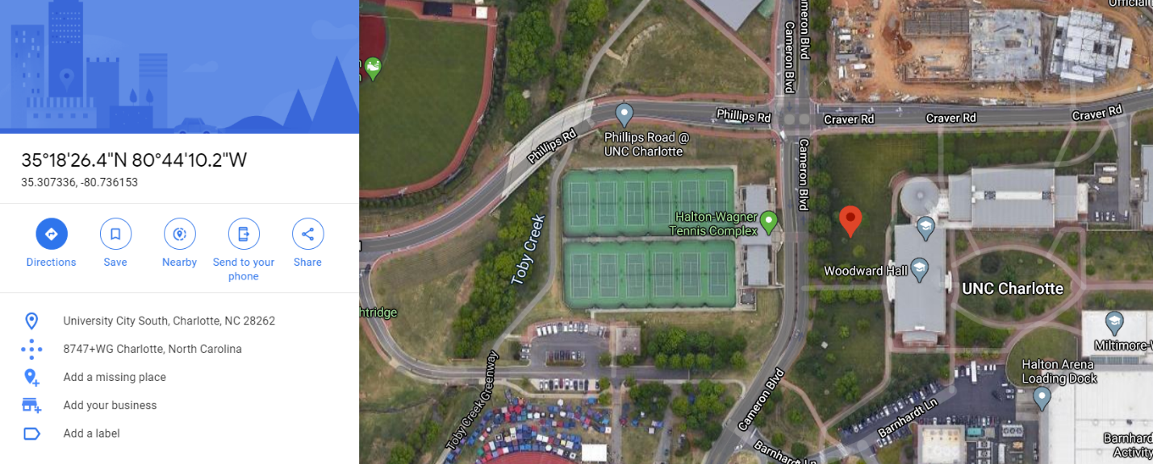

**Image 3:**

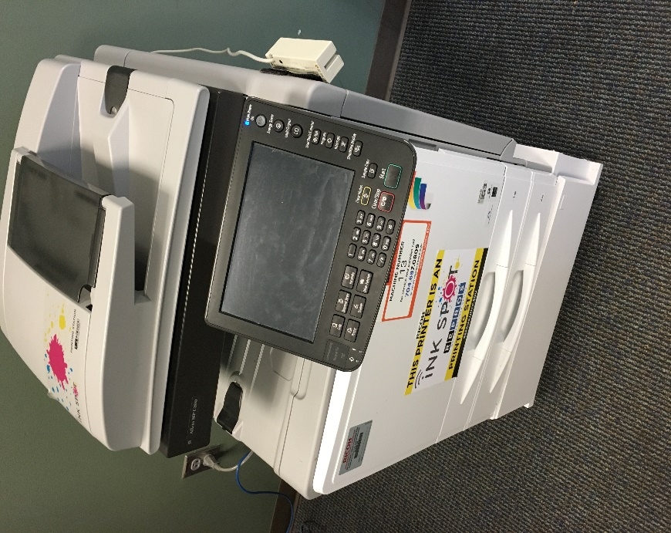

Properties of this image are as follows:

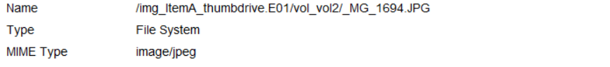

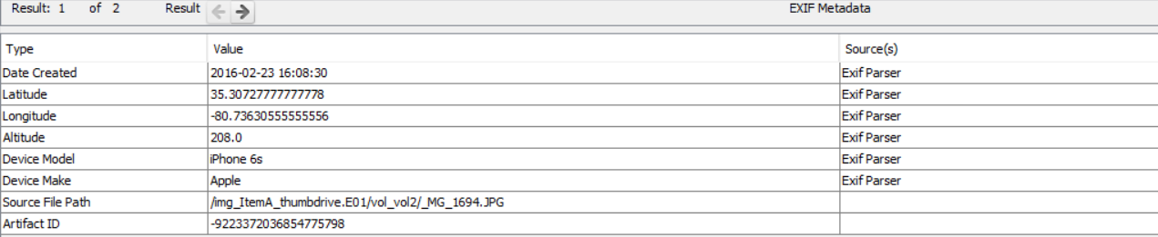

**Name:** _MG_1694.JPG

**Path:** /img_ItemA_thumbdrive.E01/vol_vol2/_MG_1694.JPG

**Device:** Apple iPhone 6s

**Date Created:** 23rd February 2016 at 16:08:30

**Latitude:** 35°18'26.2"N

**Longitude:** 80°44'10.7"W

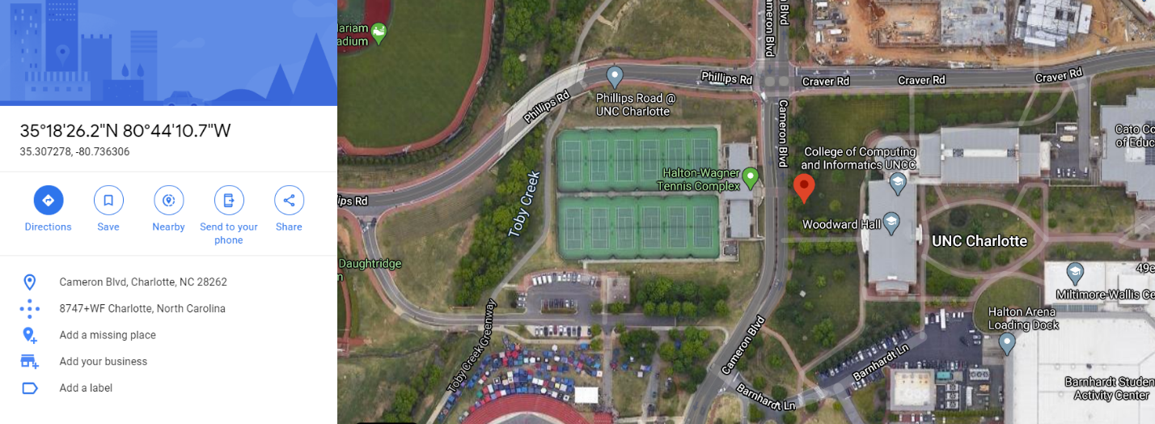

In addition to these pictures, I also found one more picture, which was deleted, using **file carving** in Autopsy. It was located in /img_ItemA_thumbdrive.E01/vol_vol2//$CarvedFiles/

**Image 4 (Carved):**

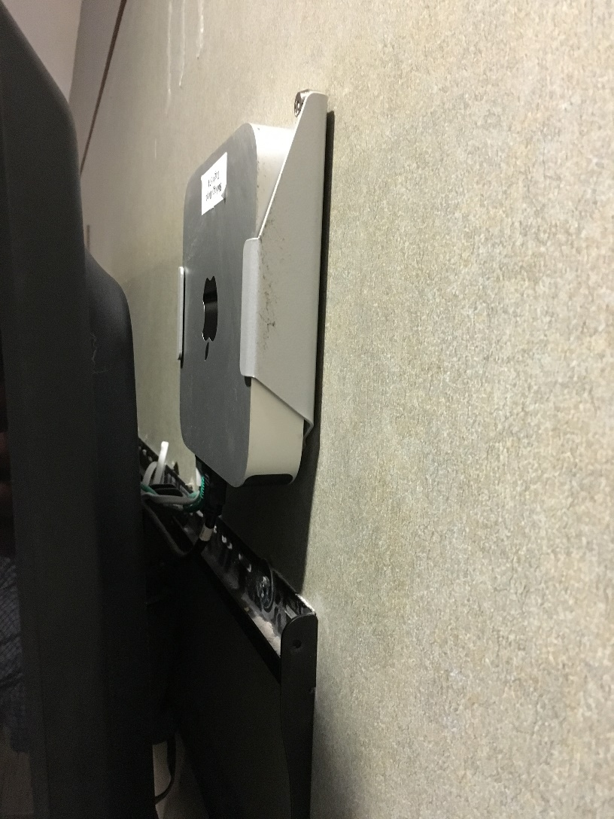

Properties of this image are as follows:



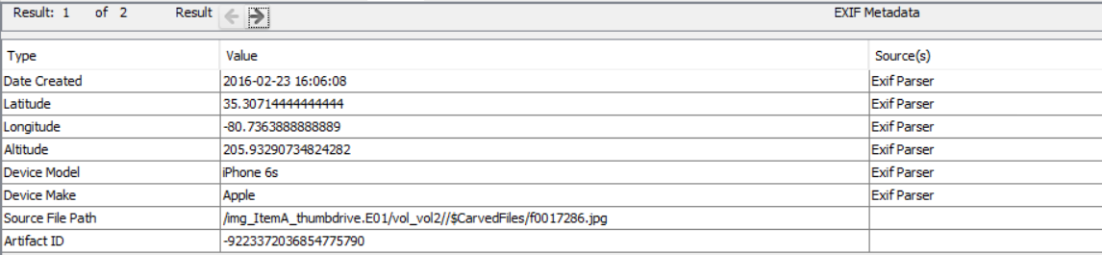

**Name:** f0017286.jpg

**Path:** /img_ItemA_thumbdrive.E01/vol_vol2//$CarvedFiles/f0017286.jpg

**Device:** Apple iPhone 6s

**Date Created:** 23rd February 2016 at 16:06:08

**Latitude:** 35°18'25.7"N

**Longitude:** 80°44'11.0"W

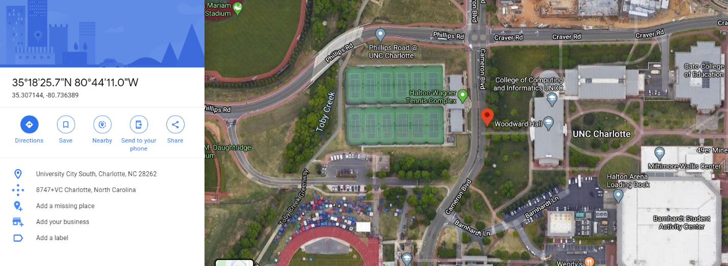

**Conclusion:**

I examined the forensic image of the thumbdrive given to me by Officer Johns and found some pictures in it which were taken on 23rd February 2016 from inside of Woodward Hall on an Apple iPhone 6s. I also performed **data carving** on the forensic image and recovered an image of a Mac Mini with a sticker on it, clicked on an iPhone 6s, which **directly links the subject to the theft**.